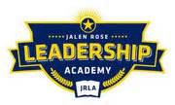

Jalen Rose Leadership Academy
Employer Sponsored Health Care Plans
FY 2018-2019

The District has contracted all health care benefits – medical, dental, and vision – through a third party vendor, Axios Incorporated. The District did not request health benefit bids.

