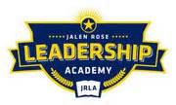

Jalen Rose Leadership Academy
Deficit Elimination Plan Transparency Report
FY 2018-2019

The District is not operating under a deficit for this fiscal year.

