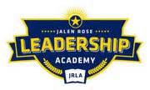

Jalen Rose Leadership Academy
Credit Card Information Transparency Report
FY 2019-2020

The District currently does not issue credit cards to staff members. However, the district does issue two debit card. See information below:
Card Type | User’s Limit | Authorized User | Last 4 Digits
Master Card | N/A | Tara Dari | 4855
Master Card | N/A | Wendie Lewis | 0021

